AZANI INTERNET SERVICE PROVIDER


Figure 1 - System Diagram
NAME:
SCHOOL CODE:
INDEX NUMBER:
PROJECT TITLE:
YEAR OF EXAMINATION:
SCHOOL:
DECLARATION
STUDENT'S DECLARATION
I, [Your Name], solemnly declare that the documentation presented herein titled "Computerized Database System for Azani Internet Service Provider" is my original work.
I affirm that:
- All the content included in this documentation is the result of my own research, analysis, and interpretation.
- Any external sources of information used in this documentation have been duly cited and referenced in accordance with academic standards.
- I have not presented any plagiarized or unauthorized material in this documentation.
- I have complied with all academic regulations and ethical standards throughout the process of creating this documentation.
- Any contributions or assistance received from others in the completion of this documentation have been acknowledged appropriately.
I acknowledge that this documentation represents my understanding and capabilities as a student of [Your School/Institution]. I take full responsibility for the accuracy and integrity of the content presented herein.
Signed: _______________________
Date: _________________________
[Your Signature]

Figure 2 - System Diagram

SUPERVISOR DECLARATION
As the supervising teacher for the development of the computerized database system titled "Azani Internet Service Provider System," I hereby attest to the following:
- I have provided guidance and support to the student, [Student's Name], throughout the process of conceptualizing, designing, and implementing the database system.
- I have ensured that the student has adhered to academic standards and guidelines in the creation of this documentation.
- I have reviewed the content of this documentation and verified its compliance with the requirements outlined by the Kenya National Examinations Council (KNEC) for the Computer Studies Project.
- I confirm that the work presented in this documentation is the original work of the student, with appropriate acknowledgment of any external sources used.
- I have verified that the student has followed ethical practices and academic integrity in the development of the database system and its documentation.
I hereby endorse the submission of this documentation as a valid and authentic representation of the student's work for the completion of their Computer Studies Project.
Signed: _______________________
Name: [Teacher's Name]
Date: _________________________

Figure 3 - System Diagram

DEDICATION
I dedicate this documentation to:
- My family, whose unwavering support and encouragement have been my source of strength throughout this journey. Their sacrifices and belief in my abilities have made this achievement possible.
- My teachers and mentors, whose guidance and expertise have shaped my academic and personal growth. Their dedication to nurturing my intellectual curiosity has been invaluable.
- The management and staff of Azani Internet Service Provider, whose cooperation and willingness to share insights into their operations have enriched my understanding of real-world database management challenges in the ISP industry.
- My friends and classmates, whose camaraderie and shared experiences have made this academic endeavor both memorable and enjoyable. Your encouragement during challenging times has been a pillar of strength.
- All educational institutions that rely on internet services for their operations, may this system contribute to improved service delivery and operational efficiency in the education sector.
- Anyone who finds value and inspiration in this documentation, may it serve as a guide and reference in their own pursuit of knowledge and learning in database management and system development.
Your support and encouragement have been instrumental in the completion of this project. Thank you for being a part of my journey.

Figure 4 - System Diagram

ACKNOWLEDGMENT
I would like to express my heartfelt gratitude to the following individuals and organizations who have contributed to the successful completion of this documentation:
- My supervisor: I am deeply thankful to [Supervisor's Name] for their invaluable guidance, expertise, and encouragement throughout the development of this project. Their insights and constructive feedback have been instrumental in shaping the direction and quality of this documentation.
- Teachers and Mentors: I extend my appreciation to all my teachers and mentors who have imparted knowledge, wisdom, and inspiration, nurturing my intellectual curiosity and passion for computer science and database management.
- Azani Internet Service Provider: I am indebted to the management and staff of Azani Internet Service Provider for their cooperation, assistance, and provision of valuable information regarding their operations, challenges, and business processes. Their willingness to share insights and experiences has significantly enriched the content and practical relevance of this documentation.
- Family and Friends: My heartfelt thanks to my family and friends for their unwavering support, understanding, and encouragement throughout this journey. Their belief in my abilities and constant encouragement have been my pillars of strength during challenging times.
- Peers and Colleagues: I am grateful to my peers and colleagues for their camaraderie, collaboration, and exchange of ideas, which have fostered a stimulating learning environment and enriched my perspective on system development.
- Educational Institutions: I acknowledge the various educational institutions that provided valuable insights into their internet service requirements and challenges, helping me understand the practical needs that this system aims to address.
- References and Resources: I acknowledge the authors, researchers, and creators whose works have served as valuable references and resources for this documentation. Their contributions have been instrumental in broadening my understanding of database management systems and enhancing the quality of this project.
- Technology Providers: Special thanks to Microsoft Corporation for providing access to Microsoft Access, the database management system used in developing this solution.
- Any Other Individuals or Organizations: I extend my appreciation to any other individuals or organizations who have directly or indirectly contributed to this project through their support, advice, or resources.
- Finally, to the Almighty: I offer my deepest gratitude to the Almighty for granting me the strength, wisdom, perseverance, and opportunities to undertake and complete this endeavor successfully.
Your support and encouragement have been pivotal in this journey, and I am sincerely grateful for your contributions.

Figure 5 - System Diagram

TABLE OF CONTENTS
Contents
AZANI INTERNET SERVICE PROVIDER 1
TABLE OF CONTENTS 8
1.0 INTRODUCTION 13
1.1 Company Background 13
1.2 Service Structure 13
1.3 Need for Automation 14
1.4 Documentation Structure 14
1.5 Project Objectives 14
2.0 SYSTEM ANALYSIS 15
2.1 Introduction 15
2.2 Problem Definition 15
2.2.1 Data Redundancy and Inconsistency 16
2.2.2 Inadequate Client and Institution Registration 16
2.2.3 Payment Recording and Tracking Challenges 16
2.2.4 Manual Calculation Errors 17
2.2.5 Limited Financial Analysis and Reporting 17
2.2.6 Inefficient Service Tracking 18
2.2.7 Report Generation Challenges 18
2.2.8 Compliance and Accountability Issues 18
2.2.9 Scalability Limitations 19
2.3 Problem Solution 19
2.3.1 Elimination of Data Redundancy 19
2.3.2 Comprehensive Registration System 20
2.3.3 Automated Payment Processing 20
2.3.4 Accurate Automated Calculations 21
2.3.5 Comprehensive Financial Analysis 21
2.3.6 Efficient Service Management 21
2.3.7 Advanced Reporting Capabilities 22
2.3.8 Enhanced Data Security and Compliance 22
2.3.9 Scalability and Future Growth 22
2.4 Overview of the Current System 23
2.4.1 Existing System 23
2.4.2 System Structure 25
2.5 Overview of the Proposed System 29
2.5.1 System Objectives 29
2.5.2 Scope of the System 30
2.5.3 Benefits of the New System 32
2.5.4 Feasibility Study 34
3.0 System design 35
3.1 System flowchat 35
3.2 Programme flowchart 39
3.3 Table design 41
3.3.1 INSTITUTION TABLE 41
3.3.2 CLIENT TABLE 41
3.3.3 DESIRED BANDWIDTH TABLE 41
3.3.4 INSTALLMENT FEE TABLE 42
3.4 ENTITY RELATIONSHIP 42
3.5 FORM DESIGN 43
3.5.1 CLIENT FORM 43
3.5.2 INSTITUTION FORM 43
3.5.3 DESIRED BANDWIDTH FORM 44
3.5.4 INSTALLMENT FEE FORM 45
3.6 REPORT DESIGN 46
3.6.1 CLIENT REPORT 46
3.6.2 INSTITUTION REPORT 47
3.6.2 DESIRED BANDWIDTH REPORT 48
NSTALLLMENT FEE REPORT 48
4.0 STORAGE AND DESIGN REQUIREMENTS 49
4.1 STORAGE REQUIREMENTS 49
4.2 PROCESSING REQUIREMENTS 49
4.3 SYSTEM CONTOL AND BACKUP 49
5.0 SYSTEM CONSTRUCTION 51
5.1 INTRODUCTION 51
5.2 DATABASE RELATIONSHIP DIAGRAM 51
5.2.1 Enforcing Referential Integrity 52
5.3 TABLES 52
5.3.1 CLIENT TABLE 52
5.3.2 INSTITUTION TABLE 55
5.3.3 DESIRED BANDWIDTH TABLE 57
5.3.4 INSTALLMENT FEE TABLE (LAN Infrastructure) 59
5.4 FORMS 61
5.4.1 CLIENT FORM 61
5.4.2 INSTITUTION FORM 64
5.4.3 DESIRED BANDWIDTH FORM 66
5.4.4 INSTALLMENT FEE FORM (LAN Infrastructure Form) 69
5.5 QUERIES 72
5.5.1 CLIENT QUERY 72
5.5.2 INSTITUTION QUERY 73
5.5.3 DESIRED BANDWIDTH QUERY 75
5.5.4 INSTALLMENT FEE QUERY (LAN Infrastructure Query) 78
5.5.5 COMPREHENSIVE REVENUE QUERY 80
5.6 REPORTS 81
5.6.1 CLIENT REPORT 81
6.0 SYSTEM IMPLEMENTATION 82
6.0 SYSTEM TESTING 82
6.1 INTRODUCTION 82
6.2 TEST PLAN 82
6.2.1 Test Objectives 82
6.2.2 Test Scope 83
6.3 DATA VALIDATION TESTING 83
6.3.1 CLIENT TABLE TESTING 83
6.3.3 DESIRED BANDWIDTH TABLE TESTING 85
6.6 REPORT TESTING 86
6.6.1 Client Report Testing 86
6.6.2 Bandwidth Report Testing 87
6.7 RELATIONSHIP INTEGRITY TESTING 87
6.7.1 Foreign Key Constraint Testing 87
6.8 USER INTERFACE TESTING 89
6.8.1 Form Navigation Testing 89
6.0 SYSTEM IMPLEMENTATION 89
6.1 INTRODUCTION 89
6.1.1 Normal Data 89
6.1.2 Absolute Data 90
6.1.3 Extreme data 90
6.2 RUNNING THE SYSTEM 90
6.3 NAVIGATION 91
7.0 SYSTEM IMPLEMENTATION 92
7.1 INTRODUCTION 92
7.2 CHANGEOVER METHOD 92
7.3 IMPLEMENTATION SCHEDULE 92
7.4 STAFF TRAINING 93
8.0 USER MANUAL 93
8.1 INSTALLING THE SYSTEM 93
8.2 INSTALLMENT REQUIREMENTS 93
8.2.1 HARDWARE CONSIDERATION 93
2.4 GHz Microprocessor 93
8.2.2 SOFTWARE CONSIDERATIONS 94
8.3 LOADING PROCESS 94
8.4 NAVIGATION GUIDE 94
8.4.1 INPUT DATA 94
8.4.2 GENERATING OUTPUTS 94
8.4.3 EXITING THE APPLICTION 94
9.0 MISCELLANEUOS 95
9.1 CONCLUSION 95
9.2 RECOMMENDATION 95
9.3 Bibliography 95
9.4 APPENDIX 95

1.0 INTRODUCTION
The following documentation presents the design and implementation of a computerized database system for Azani Internet Service Provider, a prominent internet service provider specializing in serving educational institutions across Kenya. With a commitment to bridging the digital divide in education, Azani provides comprehensive internet services and infrastructure to primary schools, junior schools, senior schools, and colleges throughout the country.
In today's rapidly evolving digital landscape, reliable internet connectivity has become essential for educational institutions to deliver quality education, facilitate research, and prepare students for the digital age. Azani Internet Service Provider plays a crucial role in this ecosystem by offering tailored internet solutions that meet the specific needs of educational institutions.

1.1 Company Background
Azani Internet Service Provider operates as a specialized ISP focusing exclusively on the education sector. The company offers a range of services designed to meet the varying bandwidth requirements and infrastructure needs of different types of educational institutions. Services include:
- Internet Connectivity: Multiple bandwidth packages ranging from 4Mbps to 40Mbps
- Local Area Network (LAN) Infrastructure: Complete network setup with varying node capacities
- Technical Support: Installation, maintenance, and troubleshooting services
- Service Customization: Tailored solutions based on institutional requirements

1.2 Service Structure
Registration Requirements: Educational institutions interested in Azani's services are required to pay a one-time registration fee of Ksh 8,500. This registration grants access to the company's service portfolio and establishes the client-provider relationship.
Internet Service Packages: The company offers various internet bandwidth packages with monthly charges based on connection speed:
Table 1 - Data Table
Bandwidth | Monthly Cost
4Mbps | Ksh 1,200
10Mbps | Ksh 2,000
20Mbps | Ksh 3,500
25Mbps | Ksh 4,000
40Mbps | Ksh 7,000
Local Area Network (LAN) Services: Institutions can also purchase LAN infrastructure with pricing based on the number of network nodes required:
Table 2 - Data Table
Node Range | Installation Cost
2-10 nodes | Ksh 10,000
11-20 nodes | Ksh 20,000
21-40 nodes | Ksh 30,000
41-100 nodes | Ksh 40,000

1.3 Need for Automation
In response to the growing client base and increasing complexity of managing institutional information, service subscriptions, fee calculations, and revenue tracking, there arises a critical need for an efficient and systematic database system. The current manual processes have become increasingly inadequate, leading to errors, inefficiencies, and challenges in providing quality service to clients.
This documentation aims to address this need by outlining the development of a comprehensive database system using Microsoft Access. The system is designed to streamline operations, enhance data organization, facilitate accurate financial calculations, and provide valuable insights for strategic decision-making.

1.4 Documentation Structure
Through the following chapters, this documentation will delve into:
- System Analysis: Examination of current challenges and proposed solutions
- System Design: Detailed design specifications including flowcharts, database tables, forms, and reports
- System Construction: Implementation details and technical specifications
- System Testing: Validation and verification procedures
- System Implementation: Deployment strategy and training programs
- User Manual: Comprehensive guide for system users
- System Review: Evaluation and recommendations for continuous improvement

1.5 Project Objectives
The successful implementation of this database system is anticipated to:
- Centralize client and service information management
- Automate financial calculations and invoicing processes
- Eliminate data redundancy and improve data integrity
- Generate comprehensive reports for management decision-making
- Enhance operational efficiency and customer service delivery
- Provide scalable infrastructure for business growth
With a focus on meeting the specific requirements of Azani Internet Service Provider and adhering to the standards set forth by the Kenya National Examinations Council (KNEC) for the Computer Studies Project, this documentation serves as a comprehensive guide for the development of an effective database solution tailored to the needs of a real-world business environment.
The successful implementation of this system will contribute to Azani's operational efficiency, data management capabilities, and overall success in delivering high-quality internet services to educational institutions across Kenya, ultimately supporting the advancement of digital education in the country.

Figure 6 - System Diagram

2.0 SYSTEM ANALYSIS

2.1 Introduction
System analysis is a critical phase in the development of any information system. It involves a comprehensive examination of the existing system, identification of problems and challenges, and the formulation of solutions through the design of a new system. This chapter presents a detailed analysis of Azani Internet Service Provider's current operations and proposes a computerized database system to address identified challenges and enhance operational efficiency.
The analysis encompasses problem definition, examination of the existing system structure, overview of the proposed solution, feasibility studies, fact-finding methodologies, and detailed system requirements. Through this systematic approach, we aim to develop a solution that not only addresses current challenges but also positions Azani Internet Service Provider for future growth and competitive advantage in the educational technology services sector.

2.2 Problem Definition
Azani Internet Service Provider, despite its important role in providing internet services to educational institutions, faces several critical challenges in managing its operations efficiently and effectively. These challenges stem from the manual and decentralized nature of its current data management processes, which lack integration and automation. The following are the key problems identified:

2.2.1 Data Redundancy and Inconsistency
The current manual system suffers from significant data redundancy, with client and institutional information being recorded multiple times across different registers and documents. This redundancy leads to:
- Duplicate records of the same institution in different ledgers
- Inconsistent data across various documentation
- Wasted storage space with repeated information
- Increased likelihood of errors during data retrieval
- Difficulty in maintaining data integrity across multiple sources
- Confusion when multiple versions of the same information exist
- Challenges in updating information consistently across all records

2.2.2 Inadequate Client and Institution Registration
The company lacks a systematic approach to registering institutions and capturing their complete details. Current challenges include:
- Incomplete institutional details in manual records
- No unique identification system for each institution
- Difficulty in categorizing institutions by type (primary schools, junior schools, senior schools, colleges)
- Missing or outdated contact information
- Inability to maintain comprehensive institutional profiles
- No standardized registration process
- Lack of verification mechanisms for registration data
- Difficulty in tracking registration dates and renewal periods

2.2.3 Payment Recording and Tracking Challenges
The manual recording of payments presents numerous difficulties:
- No systematic way to capture and track registration fees
- Difficulty in monitoring monthly bandwidth charges
- Inability to systematically track LAN installation payments
- No automated system for recording reconnection fees and penalties
- Missing or incomplete payment histories
- Challenges in tracking overdue payments
- Manual reconciliation of payments with services provided
- Difficulty in generating payment reports and summaries
- No automated payment reminder system

2.2.4 Manual Calculation Errors
Fee calculations performed manually are prone to errors and inconsistencies:
- Miscalculation of total installation costs for institutions
- Errors in computing monthly charges based on bandwidth selection
- Incorrect calculation of LAN node charges
- Manual errors in applying rates from pricing tables
- Inconsistent application of fees across different clients
- Time-consuming recalculation processes when errors are discovered
- Difficulty in handling multiple service combinations
- Errors in computing aggregated charges
- Challenges in calculating overdue fines and reconnection fees

2.2.5 Limited Financial Analysis and Reporting
The lack of a centralized database system inhibits the company's ability to perform comprehensive financial analysis:
- Difficulty in determining total revenue per service type
- Inability to track revenue trends over time
- No automated aggregation of charges by institution
- Challenges in generating financial reports for management
- Limited visibility into business performance metrics
- Inability to forecast revenue accurately
- Difficulty in identifying most profitable services
- Challenges in budget planning and resource allocation
- No systematic financial audit trail

2.2.6 Inefficient Service Tracking
The company struggles to effectively track services provided to institutions:
- No systematic record of bandwidth packages subscribed by each institution
- Difficulty in tracking LAN infrastructure installations
- Inability to monitor service upgrade history
- Challenges in managing service discontinuation and reconnections
- No automated alerts for service renewals
- Difficulty in tracking service quality and uptime
- Inability to analyze service utilization patterns
- Challenges in capacity planning

2.2.7 Report Generation Challenges
Manual compilation of reports is time-consuming and error-prone:
- Significant time required to generate client lists
- Difficulty in creating service-specific reports
- Inability to sort and filter data effectively
- No standardized report formats
- Limited ability to generate ad-hoc reports for decision-making
- Manual aggregation of data from multiple sources
- Inconsistent reporting periods and formats
- Difficulty in sharing reports with stakeholders

2.2.8 Compliance and Accountability Issues
With manual data management processes, ensuring compliance and accountability becomes challenging:
- Lack of comprehensive audit trails for transactions
- Difficulty in verifying historical data
- No systematic backup procedures
- Risk of data loss due to physical damage or misplacement
- Limited data security measures
- Challenges in meeting regulatory requirements
- Vulnerability to fraud and unauthorized access
- Difficulty in demonstrating compliance during audits

2.2.9 Scalability Limitations
As the company grows and serves more institutions, the manual system becomes increasingly inadequate:
- Inability to handle growing data volumes efficiently
- Increasing time requirements for routine tasks
- Growing administrative burden on staff
- Difficulty in expanding service offerings
- Limited capacity for business growth
- Challenges in managing multiple service locations
- Inability to support real-time data access
- Difficulty in maintaining service quality as scale increases

2.3 Problem Solution
The proposed computerized database system for Azani Internet Service Provider aims to comprehensively address all identified challenges through automation, centralization, and systematic data management. The solution encompasses the following key components:

2.3.1 Elimination of Data Redundancy
The new system will:
- Implement a normalized database structure to eliminate data duplication
- Establish referential integrity constraints to ensure data consistency
- Create a single source of truth for all institutional and client information
- Utilize primary and foreign keys to link related data without repetition
- Implement data validation rules to prevent duplicate entries
- Provide data deduplication mechanisms
- Ensure consistency through database normalization (3NF)

2.3.2 Comprehensive Registration System
The solution will enable:
- Complete capture of institutional details including name, address, contact information, and location
- Automatic assignment of unique identification codes to each institution
- Systematic categorization of institutions by type
- Storage of complete client contact information and representatives
- Maintenance of comprehensive institutional profiles with full history
- Standardized registration workflow with validation
- Easy retrieval and updating of client information
- Registration date tracking and renewal management

2.3.3 Automated Payment Processing
The system will facilitate:
- Automatic recording and tracking of registration fees
- Systematic tracking of monthly bandwidth charges
- Comprehensive recording of LAN installation payments
- Monitoring of reconnection fees and overdue charges
- Complete payment history for each institution with timestamps
- Automated payment reminders and alerts
- Payment reconciliation with services provided
- Multiple payment method support
- Automated receipt generation

2.3.4 Accurate Automated Calculations
The new system will provide:
- Automatic calculation of total installation costs based on selected services
- Precise computation of monthly charges according to bandwidth selection
- Accurate LAN node charges based on node count ranges
- Error-free application of pricing tables with version control
- Consistent fee calculation across all clients
- Automatic recalculation when service parameters change
- Built-in validation to ensure calculation accuracy
- Support for promotional pricing and discounts
- Computation of aggregate charges and totals

2.3.5 Comprehensive Financial Analysis
The system will enable:
- Real-time tracking of revenue by service type
- Automated aggregation of charges by institution
- Generation of financial summaries and comprehensive reports
- Trend analysis for revenue forecasting
- Performance metrics dashboards for management
- Cost-benefit analysis capabilities
- Profitability analysis by client segment and service type
- Budget tracking and variance analysis
- Financial KPI monitoring

2.3.6 Efficient Service Management
The solution will support:
- Complete tracking of services subscribed by each institution
- Detailed recording of bandwidth packages and LAN installations
- Service upgrade and downgrade history with timestamps
- Automated service renewal notifications and reminders
- Management of service suspensions and reconnections
- Service utilization analytics and reporting
- Capacity planning tools
- Service level agreement (SLA) tracking

2.3.7 Advanced Reporting Capabilities
The system will provide:
- Automated generation of various reports (clients, services, payments, revenue)
- Customizable report parameters and filters
- Sorting and grouping capabilities across multiple dimensions
- Export functionality to various formats (PDF, Excel, Word)
- Scheduled report generation and distribution
- Ad-hoc query capabilities for management decision-making
- Interactive dashboards and visualizations
- Comparative analysis reports

2.3.8 Enhanced Data Security and Compliance
The solution will ensure:
- Comprehensive audit trails for all transactions with user tracking
- Secure data storage with encryption mechanisms
- User authentication and role-based authorization controls
- Compliance with data protection regulations
- Disaster recovery capabilities with backup systems
- Regular automated backups to prevent data loss
- Access logging and monitoring
- Data privacy and confidentiality protection

2.3.9 Scalability and Future Growth
The system will be designed to:
- Handle increasing volumes of data efficiently
- Support business expansion and new service offerings
- Accommodate additional institutions without performance degradation
- Allow for future enhancements and feature additions
- Provide a foundation for digital transformation
- Support multiple concurrent users
- Enable cloud migration if needed in future
- Integrate with other systems as required
Through this comprehensive solution, Azani Internet Service Provider will transition from a manual, error-prone system to an efficient, automated database system that supports business growth, improves customer service, and provides valuable insights for strategic decision-making.

2.4 Overview of the Current System

2.4.1 Existing System
Azani Internet Service Provider currently operates with a predominantly manual system for managing its business operations. The company specializes in providing internet services and infrastructure to educational institutions across Kenya, serving primary schools, junior schools, senior schools, and colleges.
Current Operational Process:
The existing system relies heavily on paper-based documentation and manual record-keeping:
- Client Acquisition: When an educational institution expresses interest in Azani's services, representatives visit the company offices to apply. Basic information is recorded manually on application forms using pen and paper.
- Service Registration: Institutions pay the registration fee of Ksh 8,500, which is recorded in a receipt book with manual carbon copies. Client details are then entered into a physical client register.
- Service Selection: Clients discuss their bandwidth and infrastructure requirements with company staff. Available services and pricing are shown using printed rate cards.
- Manual Cost Calculation: Staff members manually calculate the total costs by:
  - Referring to the bandwidth pricing table
  - Calculating LAN node costs based on quantity
  - Using calculators to compute totals
  - Writing quotations by hand
- Record Storage: All client information, service subscriptions, and payment records are stored in:
  - Physical files and folders organized in filing cabinets
  - Ledger books for financial transactions
  - Spreadsheets (maintained inconsistently by different staff members)
  - Handwritten forms and notes
  - Receipt books and invoice pads
- Service Delivery Documentation: When technical teams install services, they complete manual service forms that are returned to the office and filed.
- Payment Processing: Monthly payments are recorded manually in:
  - Receipt books with carbon copies
  - Cash books for daily transactions
  - Client-specific ledger accounts
  - General ledgers for company accounts
- Reporting: Reports are created by:
  - Manually compiling data from various sources
  - Hand-calculating totals and summaries
  - Typing reports using word processing software
  - Photocopying for distribution
Characteristics of the Existing System:
- Decentralized: Information is scattered across multiple physical locations and formats
- Manual: All processes require human intervention and manual data entry
- Paper-based: Primary reliance on physical documents and handwritten records
- Time-consuming: Simple tasks require significant time to complete
- Error-prone: High risk of calculation and transcription errors
- Limited accessibility: Information retrieval is slow and cumbersome
- No real-time data: Information is often outdated by the time it's compiled
- Single-user access: Only one person can access a file at a time

2.4.2 System Structure
The current manual system follows a linear, sequential structure with multiple dependencies:
1. Institution Registration Process:
Institution visits office →
Manual application form completion →
Payment of registration fee →
Recording in client register →
Assignment of physical file folder →
Storage in filing cabinet →
Manual filing of supporting documents
2. Service Selection and Costing Process:
Client discusses requirements →
Staff reviews service options →
Manual lookup of rates in pricing table →
Manual calculation using calculator →
Handwritten quotation prepared →
Quotation copied for records →
Filed in client folder →
Quotation delivered to client
3. Payment Processing Workflow:
Client makes payment →
Receipt written manually (original + copies) →
Entry in daily cash book →
Entry in client ledger →
Entry in service-specific register →
Filing of receipt copies →
Monthly reconciliation (manual)
4. Service Activation Process:
Payment verification (manual ledger check) →
Service order form completion →
Dispatch to technical team →
Installation and setup by technicians →
Completion form returned to office →
Filing in client folder →
Update to service register
5. Monthly Billing Cycle:
Manual review of active clients →
Lookup of subscribed services →
Manual calculation of monthly charges →
Handwritten invoice preparation →
Invoice numbering and registration →
Physical delivery or collection →
Payment tracking in ledger →
Follow-up on overdue payments (manual list)
6. Report Generation Process:
Request for report received →
Identification of required data sources →
Manual gathering of files and ledgers →
Data extraction and compilation →
Manual calculations and summaries →
Typing of report →
Verification and corrections →
Distribution of report
Data Flow in Current System:
- Input: Manual data entry on forms, registers, and ledgers
- Processing: Manual calculations, sorting, and organization
- Storage: Physical files, ledger books, and occasionally spreadsheets
- Output: Handwritten reports and manually compiled summaries
- Feedback: Manual verification, error correction, and adjustments
File Organization:
The company maintains several types of physical files:
- Client Files: Individual folders for each institution containing:
  - Registration forms
  - Quotations and invoices
  - Payment receipts
  - Service agreements
  - Correspondence
- Financial Ledgers:
  - General ledger (overall company finances)
  - Client-specific ledgers
  - Cash book (daily transactions)
  - Bank reconciliation books
- Service Registers:
  - Bandwidth subscription register
  - LAN installation register
  - Service upgrade/downgrade log
  - Reconnection register
- Administrative Files:
  - Monthly summary reports
  - Service rate cards
  - Policy documents
  - Staff records
Limitations of Current Structure:
- Sequential Dependencies: Each step must be completed before the next can begin, creating bottlenecks
- Single Point of Access: Only one person can access a physical file at a time, limiting productivity
- No Real-time Updates: Information becomes outdated quickly; no immediate reflection of changes
- Limited Search Capability: Finding specific information requires manual searching through multiple files and registers
- No Automated Alerts: No system for reminders, notifications, or deadline warnings
- Difficult Consolidation: Aggregating data from multiple sources is extremely time-consuming and error-prone
- Vulnerable to Loss: Physical documents can be lost, damaged by water/fire, or destroyed
- No Systematic Backup: Limited or no backup copies of critical information; risk of total data loss
- Space Requirements: Physical storage requires significant office space
- Retrieval Time: Locating specific information can take hours or even days
- Concurrent Access Issues: Multiple staff members cannot work with the same data simultaneously
- Version Control: No mechanism to track document versions or changes over time
This manual structure, while functional at a small scale, presents significant challenges as the company grows and serves more institutions. The proposed computerized system will address these structural limitations through digital transformation, automation, and centralized data management.

2.5 Overview of the Proposed System

2.5.1 System Objectives
The proposed computerized database system has been designed with clear objectives that will transform Azani Internet Service Provider's operations. The new developed system will be able to:
Primary Objectives:
i. Centralized Data Management
- Record complete institutional details in a centralized database
- Assign automatic unique identification codes to each institution
- Maintain a comprehensive, searchable repository of all client information
- Eliminate data redundancy through normalized database design
ii. Automated Reporting System
- Generate comprehensive reports of all transactions automatically
- Provide real-time access to business intelligence
- Create customizable reports based on various parameters
- Export reports in multiple formats for different stakeholders
iii. User-Friendly Data Entry
- Implement intuitive forms for easy data input
- Reduce data entry time through automation and validation
- Minimize training requirements with user-friendly interfaces
- Provide data entry assistance through dropdown menus and auto-completion
Secondary Objectives:
iv. Financial Management - Automate all fee calculations and eliminate manual errors - Track payments and generate invoices automatically - Monitor revenue streams by service type - Provide financial analytics and forecasting tools
v. Service Tracking
- Maintain complete records of services provided to each institution
- Track bandwidth subscriptions and LAN installations
- Monitor service upgrades, downgrades, and modifications
- Manage service renewals and disconnections systematically
vi. Data Integrity and Security - Implement access controls and user authentication - Maintain audit trails for all transactions - Provide data backup and recovery mechanisms - Ensure data privacy and confidentiality

2.5.2 Scope of the System
The computerized database system will encompass the following functional areas:
i. Institution and Client Management
- Register and maintain a comprehensive list of educational institutions
- Store complete institutional profiles including:
  - Institution name and unique ID
  - Physical address and location details
  - Contact information (telephone, email)
  - Institution category (primary, junior, senior school, college)
  - Representative information
  - Registration dates and status
ii. Service Registration and Management
- Register services offered with complete infrastructure details
- Track bandwidth packages subscribed by each institution
- Record LAN infrastructure installations with node counts
- Maintain service activation and deactivation dates
- Track service modifications and upgrade history
iii. Automated Financial Computations
The system will compute each of the following automatically:
a. Total Installation Cost for Each Institution
- Registration fee (Ksh 8,500)
- Selected bandwidth package setup costs
- LAN infrastructure installation based on node count
- Any additional setup charges
- Total initial investment required
b. Cost of LAN Services
- Accurate calculation based on node ranges:
  - 2-10 nodes: Ksh 10,000
  - 11-20 nodes: Ksh 20,000
  - 21-40 nodes: Ksh 30,000
  - 41-100 nodes: Ksh 40,000
- Automatic application of correct pricing tier
c. Total Monthly Charges for Internet Services
- Bandwidth charges based on subscribed package:
  - 4Mbps: Ksh 1,200
  - 10Mbps: Ksh 2,000
  - 20Mbps: Ksh 3,500
  - 25Mbps: Ksh 4,000
  - 40Mbps: Ksh 7,000
- Prorated charges for partial months
- Service upgrade/downgrade adjustments
d. Total Monthly Charges Including Additional Fees
- Base bandwidth charges
- Overdue payment fines (if applicable)
- Reconnection fees for suspended services
- Any promotional discounts or credits
- Net amount payable
e. Aggregated Amount for Each Service Sorted by Institution
- Total revenue per institution
- Revenue breakdown by service type
- Historical payment summaries
- Outstanding balances and arrears
iv. Report Generation
The system will generate appropriate reports including:
- Client/Institution lists with full details
- Service subscription reports
- Financial transaction reports
- Revenue analysis reports
- Payment status reports
- Overdue accounts reports
- Service utilization statistics
- Custom ad-hoc reports based on user requirements
v. Query and Analysis Tools
- Advanced search and filter capabilities
- Data sorting and grouping functions
- Statistical analysis tools
- Trend identification and forecasting
vi. System Administration
- User account management
- Access rights and permissions control
- System configuration settings
- Data backup and restoration
- Audit trail monitoring

2.5.3 Benefits of the New System
The proposed computerized system offers numerous advantages over the current manual system:
Operational Benefits:
- Maintain Comprehensive Records: The system will maintain complete, accurate records of every transaction and interaction in the company, ensuring no information is lost or misplaced.
- Reduce Human Errors: Automation of calculations and data entry validation will significantly reduce human errors that are common in manual systems, improving accuracy and reliability.
- Prevent Data Redundancy: The normalized database structure will prevent duplicate data entry and ensure consistency across all records, eliminating confusion from multiple versions of information.
- Save Storage Space: Digital storage requires minimal physical space compared to filing cabinets and ledgers, reducing office space requirements and associated costs.
- Time Efficiency: The system is significantly time-saving due to automatic processing of data, instant updating of files, and rapid information retrieval, allowing staff to focus on value-added activities.
Additional Benefits:
- Enhanced Decision-Making: Real-time access to accurate data and comprehensive reports will enable management to make informed, timely decisions.
- Improved Customer Service: Faster response times, accurate information, and professional-looking reports will enhance customer satisfaction and company reputation.
- Scalability: The system can easily accommodate business growth and increasing numbers of clients without proportional increases in administrative overhead.
- Data Security: Built-in security features protect sensitive information from unauthorized access and ensure business continuity.
- Audit Compliance: Comprehensive audit trails and systematic record-keeping facilitate compliance with regulatory requirements and simplify audit processes.
- Cost Reduction: Long-term cost savings through reduced errors, improved efficiency, and elimination of paper-based processes.
- Business Intelligence: Advanced reporting and analytics provide insights into business performance, trends, and opportunities for growth.
- Consistency: Standardized processes ensure consistent service delivery and pricing across all clients.
- Accessibility: Authorized users can access information from anywhere with proper security credentials, supporting remote work and multi-location operations.
- Integration Potential: The system can be integrated with other business systems (accounting, CRM, etc.) for comprehensive business management.

2.5.4 Feasibility Study
A comprehensive feasibility study has been conducted to assess the viability of implementing the proposed computerized database system. The study examines multiple dimensions of feasibility:
2.5.4.1 Schedule Feasibility
The project timeline has been carefully planned to ensure realistic completion within available timeframes:
Table 3 - Data Table
Activity | Duration
System Analysis | 1 month
System Design | 2 months
System Development | 2 months
Program Testing and Debugging | 1 month
Implementation and Training | 1 month
Total Project Duration | 7 months

Timeline Justification:
- Month 1: Complete analysis of current system, requirements gathering, and documentation
- Months 2-3: Design database structure

3.0 System design

3.1 System flowchat
START

INSTITUTION
REGISTRATION
INSTITUTION REGISTRATION
Name, Type, Contact details
Registration fee: ksh 8,500
Calculate the total registration fee
SITE VISIT:
Infrastructure ready? (LAN AND COMPUTERS)
Purchase Computers?
Total = Qty * 40,000
Select the desired bandwidth
NO
Yes
Yes
No
NO
25Mbps
20Mbps
50Mbps
20,000
4000
10MbpSs
4Mbps
12,000
V
HAS IT MET ALL REQUIREMENTS?
INSTALMENT FEE=1,000
Yes
Yes
Yes
Yes
Yes
Yes
No
No
No
No
No
Calculate total cost
3500
2000
Monthly payment
Record Monthly payment
Status: Paid

Yes
40,000
41-100 nodes?
No
21-40 nodes?
Installment
Fee?
11-20 nodes?
2-10 nodes?
10,000
20,000
30,000
Calculate Total Installation cost:
Installation Fee + infrastructure cost
Yes
Yes
Yes
Yes
No
Yes
NO
Monthly Internet service
Bandwidth-based billing rates

Calculate Overdue Fine
Fine=Monthly cost*0.15
Mark as DEFAULTERc
RECORD MONTHLY PAYER
STATUS: Paid
Fine=Monthly cost* 0.15
Total=Due amount+Fine+1,000
Paid by the 10th day
RECONNECTION PROCESS:
Fee: ksh 1,000
Total: Due amount+Fee+1,000
DISCONNECT SERVICE
STOP
Monthly payment
Paid on time

Yes
Yes
No
No

3.2 Programme flowchart
START

No
INSTITUTION
REGISTRATION
Calculate total cost
SITE VISIT:
Infrastructure ready?(LAN AND COMPUTERS)
INSTALLATION PROCESS:
Select Bandwidth
Installation fee: ksh 1,000
Record Bandwidth selection

INSTITUTION REGISTRATION
Name, Type, Contact details
Registration fee: ksh 8,500
Calculate the total registration fee
Purchase Computers?
Total = Qty * 40,000
Yes
Yes
No
Paid by the 10th day
Monthly payment
Paid on time

RECORD MONTHLY PAYER
STATUS: Paid
Fine=Monthly cost* 0.15
Total=Due amount+Fine+1,000
Calculate Overdue Fine
Fine=Monthly cost*0.15
Mark as DEFAULTERc
Calculate Total Installation cost:
Installation Fee + infrastructure cost
No
Yes
STOP
RECONNECTION PROCESS:
Fee: ksh 1,000
Total: Due amount+Fee+1,000
DISCONNECT SERVICE
No
Yes

3.3 Table design

3.3.1 INSTITUTION TABLE
Table 4 - Data Table
FIELD NAME | DATA TYPE | DESCRIPTION
CLIENT ID | SHORT TEXT | UNIQUE IDENTIFIER
INSTITUTION NAMEM | SHORT TEXT | THE NAME OF THE INSTITUTIONS
ADDRESS | SHORT TEXT | THE PLACE WHERE INSTITUTION IS
MOBILE NO | SHORT TEXT | CONTACT OF THE INSTITUTION
LOCATION | SHORT TEXT | PLACE OF LEARNING
INSTITUTION ID | SHORT TEXT | UNIQUE IDENTIFIER
Table 5

3.3.2 CLIENT TABLE
Table 6 - Data Table
FIELD NAME | DATA TYPES | DESCRIPTION
CLIENT ID | SHORT TEXT | UNIQUE IDENTIFIER
CLIENT NAME | SHORT TEXTG | NAME OF THE CLIENT
ADDRESS | SHORT TEXT | PLACE WHERE THE CLIENT LIVES
MOBILE NO | NUMBER | CONTACT OF THE CLIENT
LOCATION | SHORT TEXT | WHERE THE INSTITUTION IS LOCATED
CLIENT CATEGORY | SHORT TEXT | CATEGORY WHERE THE CLIENT BELONGS TO
Table 7

3.3.3 DESIRED BANDWIDTH TABLE
Table 8 - Data Table
FIELD NAME | DATA TYPE | DESCRIPTION
BANDWIDTH ID | SHORT TEXT | UNIQUE IDENTIFIER
TYPES OF BANDWIDTH | SHORT TEXT | THE VARIOUS BANDWIDTH OFFERED
PRICE | CURRENCY | THE PRICE OF THE BANDWITH
CLIENT ID | SHORT TEXT | UNIQUE IDENTIFIER
Table 9

3.3.4 INSTALLMENT FEE TABLE
Table 10 - Data Table
FIELD NAME | DATA TYPE | DESCRIPTION
INSTALMENT FEE ID | SHORT TEXT | UNIQUE IDENTIFIER
RANGE OF NODES | SHORT TEXT | THE DESIRED RANGE TO BE BOUGHT
PRICE | CURRENCY | THE PRICE OF THE NODES
CLIENT ID | SHORT TEXT | UNIQUE IDENTIFIER
Table 11

3.4 ENTITY RELATIONSHIP

DESIRED BANDWIDTH TABLE
BANDWIDTH ID
CLIENT ID
TYPES OF BANDWIDTH
PRICE

Table 12

INSTALLMENT FEE TABLE
INSTALLMENT FEE ID
CLIENT ID
RANGE OF NODES
PRICE

INSTITUTION TABLE
INSTITUTION NAME
INSTITUTION ID
CLIENT ID
ADDRESS
LOCATION

c

INSTITUTION TABLE
INSTITUTION NAME
INSTITUTION ID
CLIENT ID
ADDRESS
LOCATION

c

CLIENT TABLE
CLIENT ID
CLIENT NAME
ADDRESS
MOBILE NO
LOCATION
CLIENT CATEGORY

3.5 FORM DESIGN

3.5.1 CLIENT FORM
CLIENT FORM
CLIENT ID
CLIENT NAME
ADDRESS
LOCATION
CLIENT CATEGORY
MOBILE NO

PREVIOUS C
NEXT
SAVE
DELETE
CLOSE

form 1

3.5.2 INSTITUTION FORM
INSTITUTION FORM
CLIENT ID
INSTITUTION -ID
ADDRESS
LOCATION
INSTITUTION NAME
MOBILE NO

PREVIOUS
CLOSE
DELETE
SAVE
NEXT
form 2

3.5.3 DESIRED BANDWIDTH FORM
DESIRED BANDWIDTH FORM
BANDWIDTH ID
CLIENT ID
TYPE OF BANDWIDTH
PRICE

CLOSE
DELETE
SAVE
NEXT

form 3

3.5.4 INSTALLMENT FEE FORM
INSTALLMENT FEE FORM
INSTALLMENT FEE ID
CLIENTT ID
RANGE OF NODES
PRICE

CLOSE
DELETE
SAVE
NEXT
PREVIOUS
form 4

3.6 REPORT DESIGN

3.6.1 CLIENT REPORT
CLIENT REPORT
CLIENT ID
CLIENT NAME
ADDRESS
LOCATION
CLIENT CATEGORY
MOBILE NO

report 1

3.6.2 INSTITUTION REPORT
INSTITUTION REPORT
INSTITUTION ID
INSTITUTION NAME
CLIENT ID
ADDRESS
LOCATION
MOBILE NO

report 2

3.6.2 DESIRED BANDWIDTH REPORT
DESIRED BANDWIDTH REPORT
BANDWIDTH ID
CLIENT ID
TYPE OF BANDWIDTH
PRICE

report 3

NSTALLLMENT FEE REPORT
INSTALLMENT FEE REPORT
INSTALLMENT ID
CLIENT ID
RANGE OF NODES
PRICE

report 4

4.0 STORAGE AND DESIGN REQUIREMENTS

4.1 STORAGE REQUIREMENTS
This system has many files that need to be carefully stored to prevent loss of data. The files to be stored therefore include:
- A master file which will be used to store permanent records of the system.
- A report file will be used to hold the permanent records after they have been processed.
- A reference file which will be used to hold copies of data in preferred physical storage devices.
- A back up file which will be used too hold copies of data in preferred physical storage devices.
The method of file organization will ne Direct File Organization because:
- It allows users to update files faster than other organization methods hence saves on time.
- Users are able to store large files
- Allows easy access to the information access.
It is recommended that a hard disk be used for storage due to its high storage capacity and reliability.

PROCESSING REQUIREMENTS
Real time processing will be used because of the following reasons:
- It allows one to correct problems in the system as soon as they are identified.
- Fever resources are required to sync up the system.
- Since the information is updated almost immediately, the information is always up to date.
- There is minimal delay in processing.

SYSTEM CONTOL AND BACKUP
Since data loss is a huge risk in computerized systems, measures have to be taken to ensure that all the data is safe and secure during the processing and during storage. The measures include:
- An update anti-virus software should be installed and run occasionally so as to prevent data loss
- All files should back up in secondary storage devices such as CD—RWs
- A firewall and passwords should be set up so as to prevent unauthored access of data.
- All company computers should be fitted in Uninterrupted Power Supply Units so as to ensure that data is secure in case of black out.
- The company should incorporate the use of audit files
- The company should incorporate to use log files
- The company should incorporate the use of patches.
The data should be backed up on secondary storage devices that should be stored in a different location at the company location. Moreover, data access should be granted to trusted licensed company employees

Figure 7 - System Diagram

5.0 SYSTEM CONSTRUCTION

5.1 INTRODUCTION
System construction is the phase where the theoretical designs and specifications developed during the system design phase are transformed into a tangible, functional database system. This chapter documents the actual implementation of the Azani Internet Service Provider database system using Microsoft Access as the primary development platform.
The construction phase involved creating all database objects including tables, forms, queries, and reports based on the designs outlined in Chapter 3. Each component was carefully constructed to ensure data integrity, user-friendliness, and efficient operation. The system was built with consideration for scalability, maintainability, and adherence to database normalization principles.
This chapter provides detailed documentation of the constructed system components, including table structures with their properties, input forms for data entry, output reports for information presentation, and queries for data manipulation and retrieval. Screenshots of the actual implementation are included to provide visual reference for understanding the system's structure and functionality.

5.2 DATABASE RELATIONSHIP DIAGRAM
The database relationship diagram represents the core structure of the Azani Internet Service Provider system, showing how different tables are interconnected through primary and foreign key relationships. This diagram is crucial for understanding data flow and maintaining referential integrity throughout the system.
[IMAGE HERE - Database Relationship Diagram showing all four tables with their connections]
The relationship diagram illustrates:
- One-to-Many Relationships: The CLIENT table has one-to-many relationships with DESIRED BANDWIDTH, INSTALLMENT FEE, and INSTITUTION tables through the CLIENT_ID foreign key
- Referential Integrity: Enforced through relationship lines ensuring that child records cannot exist without corresponding parent records
- Cascade Options: Update and delete cascades are configured to maintain data consistency across related tables

5.2.1 Enforcing Referential Integrity
Referential integrity has been enforced in the system to maintain data consistency and prevent orphaned records. The following integrity constraints are implemented:
- Primary Key Constraints: Each table has a primary key that uniquely identifies records, preventing duplicate entries
- Foreign Key Constraints: Foreign keys in child tables reference primary keys in parent tables, ensuring valid relationships
- Cascade Updates: When a CLIENT_ID is updated in the CLIENT table, all related records in dependent tables are automatically updated
- Cascade Deletes: Configured selectively to prevent accidental data loss while maintaining data consistency
- Required Fields: Essential fields are set as required to prevent incomplete data entry
- Data Type Validation: Appropriate data types enforce valid data entry (e.g., Currency for prices, Short Text for IDs)

5.3 TABLES
Tables form the foundation of the database system, storing all information related to clients, institutions, bandwidth services, and installation fees. Each table has been carefully designed with appropriate field properties to ensure data integrity and efficient storage.

5.3.1 CLIENT TABLE
The CLIENT table stores comprehensive information about all clients who register with Azani Internet Service Provider. This table serves as the parent table for other related tables in the system.
[Client Table in Design View showing all fields and properties]
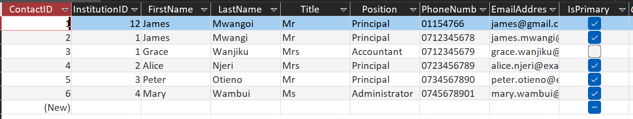
Figure 8 - System Diagram

Table Structure:
Field Name | Data Type | Field Size | Required | Description
CLIENT_ID | Short Text | 10 | Yes | Primary key, unique identifier for each client
CLIENT_NAME | Short Text | 50 | Yes | Full name of the client representative
ADDRESS | Short Text | 100 | Yes | Physical address of the client
MOBILE_NO | Short Text | 15 | Yes | Contact telephone number
LOCATION | Short Text | 50 | Yes | Geographic location of the client
CLIENT_CATEGORY | Short Text | 20 | Yes | Category (Industrial, Commercial, Domestic)
Field Properties Configuration:
- CLIENT_ID:
  - Format: "CLI" followed by sequential numbers (e.g., CLI001, CLI002)
  - Indexed: Yes (No Duplicates)
  - Input Mask: >LLL000 (ensures consistent format)
- CLIENT_NAME:
  - Validation Rule: Not empty
  - Validation Text: "Client name is required"
  - Allow Zero Length: No
- MOBILE_NO:
  - Input Mask: 0000-000-000 (Kenyan phone format)
  - Validation Rule: Length must be at least 10 digits
- CLIENT_CATEGORY:
  - Lookup properties: Combo box with three options (Industrial, Commercial, Domestic)
  - Limit to List: Yes

Sample Data:
Table 13 - Data Table
CLIENT_ID | CLIENT_NAME | ADDRESS | MOBILE_NO | LOCATION | CLIENT_CATEGORY
CLI001 | John Kamau | P.O. Box 123, Thika | 0722-456-789 | Thika Town | Commercial
CLI002 | Mary Wanjiru | P.O. Box 456, Kiambu | 0733-789-012 | Kiambu | Domestic
CLI003 | Peter Ochieng | P.O. Box 789, Nairobi | 0711-234-567 | Industrial Area | Industrial

5.3.2 INSTITUTION TABLE
The INSTITUTION table stores detailed information about educational institutions that subscribe to Azani's services. This table maintains records of schools and colleges that are the primary target market for the company.
[Institution Table in Design View showing all fields and properties]
Figure 9 - System Diagram
Table Structure:
Field Name | Data Type | Field Size | Required | Description
INSTITUTION_ID | Short Text | 10 | Yes | Primary key, unique identifier
INSTITUTION_NAME | Short Text | 100 | Yes | Official name of the educational institution
ADDRESS | Short Text | 100 | Yes | Physical/postal address
MOBILE_NO | Short Text | 15 | Yes | Institution's contact number
LOCATION | Short Text | 50 | Yes | Geographic location
CLIENT_ID | Short Text | 10 | Yes | Foreign key linking to CLIENT table

Field Properties Configuration:
- INSTITUTION_ID:
  - Format: "INS" followed by sequential numbers (e.g., INS001, INS002)
  - Indexed: Yes (No Duplicates)
  - Primary Key: Yes
- INSTITUTION_NAME:
  - Caption: "Name of Institution"
  - Required: Yes
  - Indexed: Yes (Duplicates OK) - for faster searching
- CLIENT_ID:
  - Relationship: Many-to-One with CLIENT table
  - Referential Integrity: Enforced
  - Cascade Update: Yes
  - Cascade Delete: No (to prevent accidental data loss)
Sample Data:
Table 14 - Data Table
INSTITUTION_ID | INSTITUTION_NAME | ADDRESS | MOBILE_NO | LOCATION | CLIENT_ID
INS001 | Thika High School | P.O. Box 234, Thika | 0720-111-222 | Thika | CLI001
INS002 | Kiambu Primary School | P.O. Box 567, Kiambu | 0731-333-444 | Kiambu | CLI002
INS003 | Nairobi Technical College | P.O. Box 890, Nairobi | 0712-555-666 | Nairobi | CLI003

5.3.3 DESIRED BANDWIDTH TABLE
The DESIRED BANDWIDTH table records the internet bandwidth packages selected by clients. This table is crucial for calculating monthly charges and tracking service subscriptions.
[Desired Bandwidth Table in Design View showing all fields and properties]
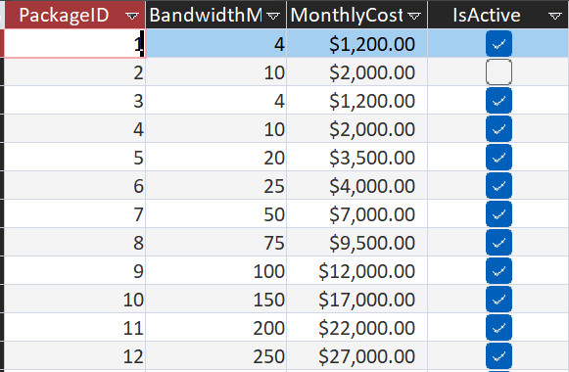
Figure 10 - System Diagram
Table Structure:
Field Name | Data Type | Field Size | Required | Description
BANDWIDTH_ID | Short Text | 10 | Yes | Primary key, unique identifier
TYPES_OF_BANDWIDTH | Short Text | 20 | Yes | Speed tier (4Mbps, 10Mbps, 20Mbps, 25Mbps, 40Mbps)
PRICE | Currency | - | Yes | Monthly subscription fee
CLIENT_ID | Short Text | 10 | Yes | Foreign key linking to CLIENT table
Field Properties Configuration:
- BANDWIDTH_ID:
  - Format: "BW" followed by sequential numbers (e.g., BW001, BW002)
  - Indexed: Yes (No Duplicates)
  - Primary Key: Yes
- TYPES_OF_BANDWIDTH:
  - Lookup properties: Combo box with five options
    - 4Mbps
    - 10Mbps
    - 20Mbps
    - 25Mbps
    - 40Mbps
  - Limit to List: Yes
  - Required: Yes
- PRICE:
  - Format: Currency
  - Decimal Places: 2
  - Default Value: Based on bandwidth selection
  - Validation Rule: >0 (must be positive)
  - Calculated automatically based on TYPES_OF_BANDWIDTH selection
Bandwidth Pricing Logic:
The system implements automatic price calculation based on the bandwidth type selected:
Table 15 - Data Table
Bandwidth Type | Monthly Price (Ksh)
4Mbps | 1,200
10Mbps | 2,000
20Mbps | 3,500
25Mbps | 4,000
40Mbps | 7,000
Sample Data:
Table 16 - Data Table
BANDWIDTH_ID | TYPES_OF_BANDWIDTH | PRICE | CLIENT_ID
BW001 | 10Mbps | Ksh 2,000.00 | CLI001
BW002 | 4Mbps | Ksh 1,200.00 | CLI002
BW003 | 40Mbps | Ksh 7,000.00 | CLI003

5.3.4 INSTALLMENT FEE TABLE (LAN Infrastructure)
The INSTALLMENT FEE table stores information about Local Area Network (LAN) infrastructure installations, including the number of nodes and associated costs. This table is essential for calculating one-time installation charges.
[ Installment Fee Table in Design View showing all fields and properties]
Table Structure:
Field Name | Data Type | Field Size | Required | Description
INSTALMENT_FEE_ID | Short Text | 10 | Yes | Primary key, unique identifier
RANGE_OF_NODES | Short Text | 20 | Yes | Node range category (2-10, 11-20, 21-40, 41-100)
PRICE | Currency | - | Yes | Installation cost for the node range
CLIENT_ID | Short Text | 10 | Yes | Foreign key linking to CLIENT table
Field Properties Configuration:
- INSTALMENT_FEE_ID:
  - Format: "INF" followed by sequential numbers (e.g., INF001, INF002)
  - Indexed: Yes (No Duplicates)
  - Primary Key: Yes
- RANGE_OF_NODES:
  - Lookup properties: Combo box with four options
    - 2-10 nodes
    - 11-20 nodes
    - 21-40 nodes
    - 41-100 nodes
  - Limit to List: Yes
  - Required: Yes
- PRICE:
  - Format: Currency
  - Decimal Places: 2
  - Validation Rule: >0 (must be positive)
  - Calculated automatically based on RANGE_OF_NODES selection
LAN Installation Pricing Logic:
The system implements automatic price calculation based on the node range selected:
Table 17 - Data Table
Node Range | Installation Cost (Ksh)
2-10 nodes | 10,000
11-20 nodes | 20,000
21-40 nodes | 30,000
41-100 nodes | 40,000
Sample Data:
Table 18 - Data Table
INSTALMENT_FEE_ID | RANGE_OF_NODES | PRICE | CLIENT_ID
INF001 | 11-20 nodes | Ksh 20,000.00 | CLI001
INF002 | 2-10 nodes | Ksh 10,000.00 | CLI002
INF003 | 41-100 nodes | Ksh 40,000.00 | CLI003

5.4 FORMS
Forms provide the user interface for data entry and manipulation within the database system. Each form has been designed with user-friendliness in mind, incorporating intuitive layouts, clear labels, and appropriate controls for efficient data entry.

5.4.1 CLIENT FORM
The CLIENT FORM is the primary data entry interface for registering new clients and managing existing client information. This form provides a clean, organized layout for capturing all essential client details.
[Client Form showing the complete form layout with all fields and navigation buttons]
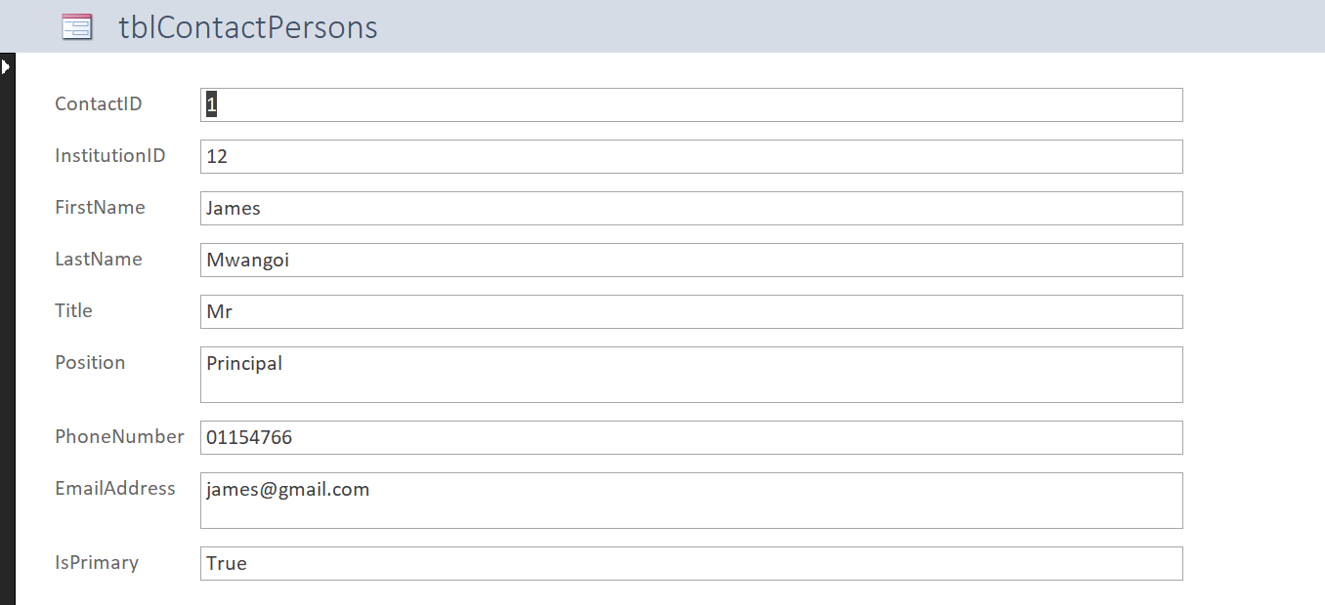
Figure 11 - System Diagram
Form Design Features:
Form Properties:
- Record Selectors: Enabled (allows users to select entire records)
- Navigation Buttons: Custom buttons replace default Access navigation
- Scroll Bars: Vertical scroll bar if form height exceeds screen
- Pop Up: No (form integrates with main window)
- Modal: No (allows access to other forms)
- Data Entry: New record on open (optional)
- Allow Additions: Yes
- Allow Deletions: Yes (with confirmation)
- Allow Edits: Yes
Form Validation and Error Handling:
The form implements several validation mechanisms:
- Required Field Validation:
  - Visual indicators (red asterisks) mark required fields
  - Form cannot be saved if required fields are empty
  - Error message displays: "Please fill in all required fields"
- Data Format Validation:
  - Phone number must match Kenyan format
  - CLIENT_ID format automatically enforced
  - Error message for invalid formats
- Duplicate Prevention:
  - System checks for duplicate CLIENT_ID before saving
  - Warning message if duplicate detected
- Save Confirmation:
  - Success message displays after successful save
  - Message: "Client record saved successfully"

5.4.2 INSTITUTION FORM
The INSTITUTION FORM is designed specifically for registering educational institutions that subscribe to Azani's services. This form captures comprehensive institutional details and links them to the corresponding client record.
[Institution Form showing complete layout with all fields]
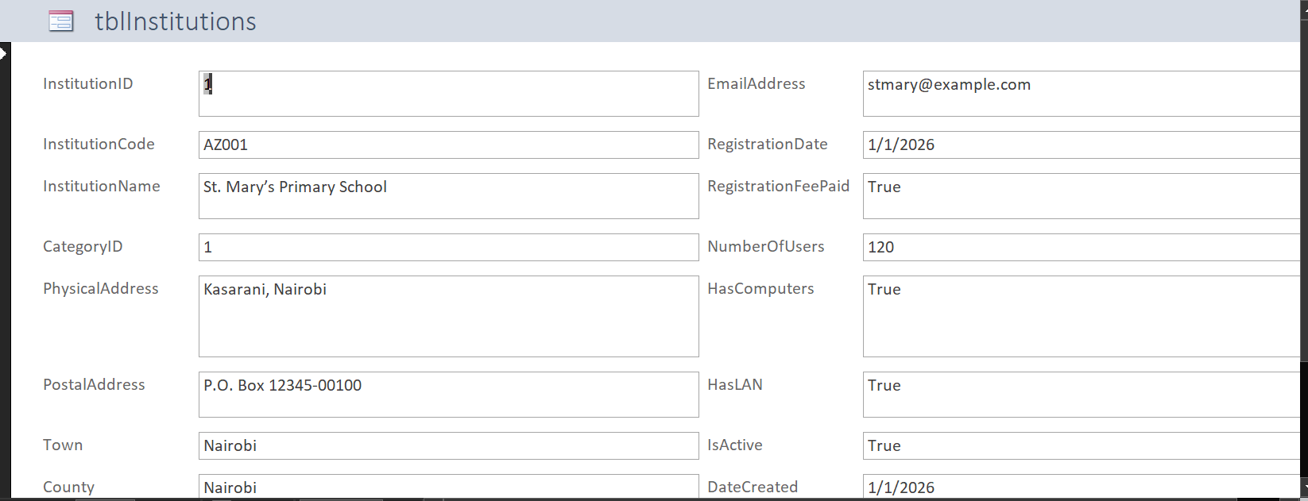
Figure 12 - System Diagram
Form Design Features:
Header Section:
- Form Title: "INSTITUTION REGISTRATION FORM"
- Subtitle: "Educational Institution Details"
- Form icon or logo
Main Data Entry Section:
- Institution Identification:
  - INSTITUTION_ID: Auto-generated (format: "INS" + number)
  - Display only field
  - Sequential numbering
- Institution Details:
  - INSTITUTION_NAME: Text box (100 characters)
  - Validation: Required, cannot be empty
  - Examples shown: "...High School", "...Primary School", "...College"
- Contact Information:
  - ADDRESS: Multi-line text box for postal/physical address
  - MOBILE_NO: Formatted input with mask
  - Validation: Valid phone number format
- Location Details:
  - LOCATION: Combo box with county/town options
  - Searchable dropdown
  - Custom entry allowed
- Client Linkage:
  - CLIENT_ID: Combo box showing existing clients
  - Displays: CLIENT_ID and CLIENT_NAME
  - Required: Must link to existing client
  - Validation: Ensures referential integrity
Special Features:
- Client Lookup: Ability to search and select from existing clients
- Institution Type Indicator: Visual distinction for different institution types
- Auto-fill Capability: If client exists, some fields auto-populate
Navigation Buttons:
Similar to Client Form:
- Previous/Next Record
- Save (with validation)
- Delete (with confirmation)
- New Record
- Close Form
Form Validation:
- Client Reference Validation:
  - Ensures selected CLIENT_ID exists in CLIENT table
  - Error message: "Please select a valid client"
- Institution Name Uniqueness:
  - Warning if similar institution name exists
  - Allows override with confirmation
- Complete Information Check:
  - All required fields must be filled
  - Comprehensive error messages for missing data

5.4.3 DESIRED BANDWIDTH FORM
The DESIRED BANDWIDTH FORM allows users to register bandwidth packages selected by clients. This form includes automatic price calculation based on the selected bandwidth tier.
[Desired Bandwidth Form showing layout and auto-calculation features]
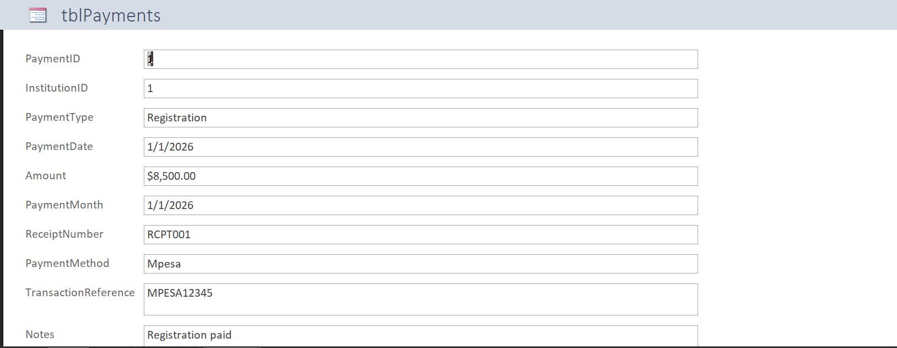
Figure 13 - System Diagram
Form Design Features:
Header Section:
- Form Title: "BANDWIDTH SUBSCRIPTION FORM"
- Subtitle: "Select Internet Speed Package"
Main Data Entry Section:
- Subscription Identification:
  - BANDWIDTH_ID: Auto-generated (format: "BW" + number)
  - Display only field
- Client Selection:
  - CLIENT_ID: Combo box showing all registered clients
  - Displays: CLIENT_ID, CLIENT_NAME, and INSTITUTION (if applicable)
  - Searchable dropdown for quick client lookup
  - Required field
- Bandwidth Selection:
  - TYPES_OF_BANDWIDTH: Combo box with five options
    - 4Mbps
    - 10Mbps
    - 20Mbps
    - 25Mbps
    - 40Mbps
  - Visual representation: Icons or graphics showing speed tiers
  - Required field
- Automatic Price Display:
  - PRICE: Calculated field (display only)
  - Updates automatically when bandwidth type is selected
  - Format: Currency (Ksh X,XXX.00)
  - Large, clear display for price confirmation
Pricing Table Display:
A reference table is displayed on the form for user convenience:
Table 19 - Data Table
Speed | Monthly Fee
4Mbps | Ksh 1,200
10Mbps | Ksh 2,000
20Mbps | Ksh 3,500
25Mbps | Ksh 4,000
40Mbps | Ksh 7,000
Special Features:
- Smart Price Calculation:
  - AfterUpdate event on TYPES_OF_BANDWIDTH field
  - VBA code automatically assigns correct price
  - No manual price entry required
- Service Recommendation:
  - Tooltip suggestions based on institution type
  - Example: "Recommended for primary schools: 4-10Mbps"
- Duplicate Subscription Check:
  - System warns if client already has active bandwidth subscription
  - Option to upgrade or modify existing subscription
Form Validation:
- Client Validation:
  - Ensures client exists and is active
  - Error: "Invalid client selection"
- Bandwidth Selection Requirement:
  - Must select a bandwidth type
  - Error: "Please select a bandwidth package"
- Price Verification:
  - System verifies calculated price matches pricing table
  - Prevents data inconsistencies
Navigation Buttons:
- Standard set (Previous, Next, Save, Delete, New, Close)
- Save button validates all entries before committing

5.4.4 INSTALLMENT FEE FORM (LAN Infrastructure Form)
The INSTALLMENT FEE FORM is used to record LAN infrastructure installations, including the number of nodes and associated costs. This form also features automatic price calculation.
[ Installment Fee Form showing node selection and automatic pricing]
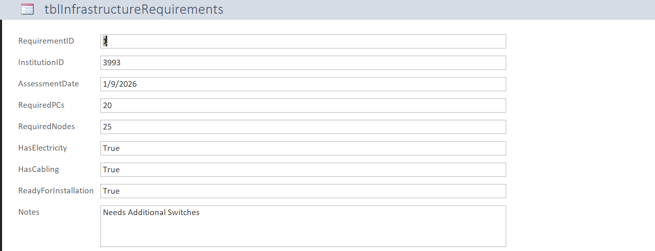
Figure 14 - System Diagram
Form Design Features:
Header Section:
- Form Title: "LAN INFRASTRUCTURE INSTALLATION FORM"
- Subtitle: "Local Area Network Setup"
Main Data Entry Section:
- Installation Identification:
  - INSTALMENT_FEE_ID: Auto-generated (format: "INF" + number)
  - Display only field
- Client Selection:
  - CLIENT_ID: Combo box showing all registered clients
  - Displays: CLIENT_ID and CLIENT_NAME
  - Searchable functionality
  - Required field
- Node Range Selection:
  - RANGE_OF_NODES: Combo box with four options
    - 2-10 nodes
    - 11-20 nodes
    - 21-40 nodes
    - 41-100 nodes
  - Visual indicators showing network size
  - Required field
- Automatic Price Display:
  - PRICE: Calculated field (display only)
  - Updates automatically when node range is selected
  - Format: Currency (Ksh XX,XXX.00)
  - Prominent display for cost confirmation
Installation Pricing Table Display:
Reference table shown on form:
Table 20 - Data Table
Node Range | Installation Cost
2-10 nodes | Ksh 10,000
11-20 nodes | Ksh 20,000
21-40 nodes | Ksh 30,000
41-100 nodes | Ksh 40,000
Special Features:
- Automatic Price Assignment:
  - VBA code in AfterUpdate event
  - Assigns price based on node range selection
  - Prevents manual price entry errors
- Node Recommendation Tool:
  - Guidance text: "Number of computers to be networked"
  - Suggestions based on institution type
  - Example: "Primary schools typically require 10-20 nodes"
- Installation Planning Notes:
  - Optional notes field for special requirements
  - Examples: Cable lengths, switch requirements, etc.
- Duplicate Installation Check:
  - Warns if client already has LAN installation
  - Suggests addition to existing network
Form Validation:
- Client Validation:
  - Ensures client exists in database
  - Checks for active client status
- Node Range Requirement:
  - Must select a node range
  - Error: "Please select the number of nodes required"
- Registration Fee Check:
  - System can verify if client has paid registration fee (Ksh 8,500)
  - Optional warning if registration pending
Additional Features:
- Total Cost Calculator: Shows total including registration fee if applicable
- Installation Date: Date picker for scheduling installation
- Technician Assignment: Optional field for assigning installation team
Navigation Buttons:
- Standard set with enhanced save validation
- Save triggers automatic calculation verification

5.5 QUERIES
Queries are essential for retrieving, filtering, and analyzing data stored in the database. The Azani system includes several queries designed to extract meaningful information and support decision-making processes.

5.5.1 CLIENT QUERY
The CLIENT QUERY retrieves comprehensive client information, allowing users to search, filter, and view client records efficiently.
[Client Query in Design View showing table relationships and selected fields]
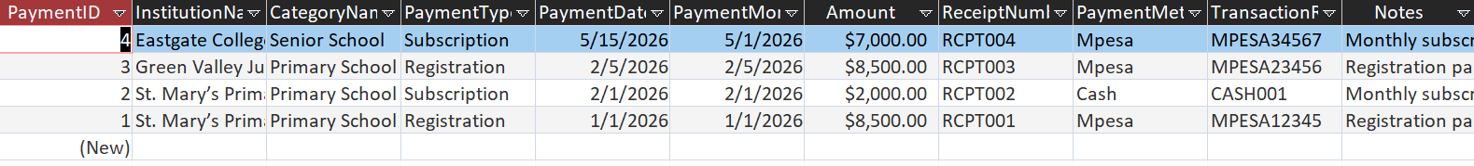
Figure 15 - System Diagram
Query Structure:
Tables Included:
- CLIENT (primary table)
Fields Selected:
- CLIENT_ID
- CLIENT_NAME
- ADDRESS
- MOBILE_NO
- LOCATION
- CLIENT_CATEGORY
Sorting:
- Primary Sort: CLIENT_NAME (Ascending)
- Secondary Sort: LOCATION (Ascending)
Criteria Options:
The query can be customized with various criteria:
- By Client Category:
  - Filter: CLIENT_CATEGORY = "Industrial" OR "Commercial" OR "Domestic"
  - Example: Show only Commercial clients
- By Location:
  - Filter: LOCATION = [Specific location]
  - Example: All clients in Thika
- By Name Search:
  - Filter: CLIENT_NAME Like "[search term]"
  - Example: All clients with "School" in their name
Query Results Display:
[Client Query Results showing sample data in datasheet view]

Figure 16 - System Diagram
The query results show:
- Organized, easy-to-read format
- All client information in columns
- Sortable by any field
- Exportable to Excel or other formats
Query Uses:
- Generate client lists for reports
- Search for specific clients
- Filter clients by category or location
- Export client data for external use

5.5.2 INSTITUTION QUERY
The INSTITUTION QUERY retrieves educational institution information along with related client details through a join operation.
[ Institution Query in Design View showing joined tables]
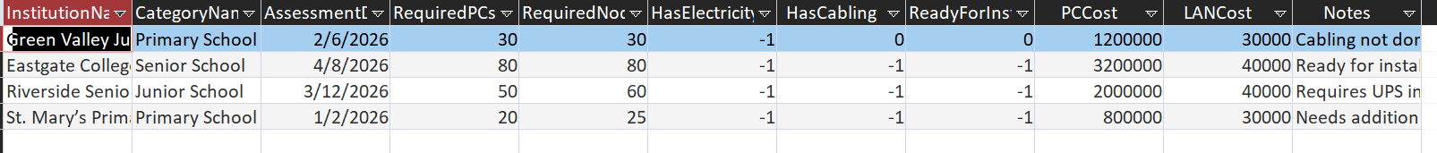
Figure 17 - System Diagram
Query Structure:
Tables Included:
- INSTITUTION (primary table)
- CLIENT (joined via CLIENT_ID)
Fields Selected:
- INSTITUTION.INSTITUTION_ID
- INSTITUTION.INSTITUTION_NAME
- INSTITUTION.ADDRESS
- INSTITUTION.MOBILE_NO
- INSTITUTION.LOCATION
- CLIENT.CLIENT_NAME (representative name)
- CLIENT.CLIENT_CATEGORY
Join Type:
- Inner Join: Shows only institutions with matching client records
- Join Field: CLIENT_ID
Sorting:
- Primary Sort: INSTITUTION_NAME (Ascending)
- Secondary Sort: LOCATION (Ascending)
Criteria Options:
- By Institution Type:
  - Filter based on keywords in INSTITUTION_NAME
  - Example: Like "High School" for secondary schools
- By Location:
  - Filter: LOCATION = [Specific area]
- By Client Representative:
  - Filter: CLIENT.CLIENT_NAME = [Specific person]
Query Results Display:
[Institution Query Results showing joined data]

Figure 18 - System Diagram
Results show:
- Institution details
- Associated client information
- Complete contact information
- Easy identification of institution representatives
Query Uses:
- Generate institution lists
- Identify client representatives for institutions
- Analyze geographic distribution
- Export for marketing purposes

5.5.3 DESIRED BANDWIDTH QUERY
The DESIRED BANDWIDTH QUERY retrieves bandwidth subscriptions along with client information and pricing details.
[Desired Bandwidth Query in Design View]
Figure 19 - System Diagram
Query Structure:
Tables Included:
- DESIRED_BANDWIDTH (primary table)
- CLIENT (joined via CLIENT_ID)
Fields Selected:
- BANDWIDTH_ID
- TYPES_OF_BANDWIDTH
- PRICE
- CLIENT.CLIENT_ID
- CLIENT.CLIENT_NAME
- CLIENT.LOCATION
Calculated Fields:
- Annual Cost:
  - Expression: [PRICE] * 12
  - Shows yearly subscription cost
  - Format: Currency
Sorting:
- Primary Sort: TYPES_OF_BANDWIDTH (Descending - highest speed first)
- Secondary Sort: CLIENT_NAME (Ascending)
Criteria Options:
- By Bandwidth Type:
  - Filter: TYPES_OF_BANDWIDTH = "4Mbps" OR "10Mbps" etc.
  - Example: All 40Mbps subscribers
- By Price Range:
  - Filter: PRICE >= [minimum] AND PRICE <= [maximum]
  - Example: Subscriptions between Ksh 2,000 and 4,000
- By Client:
  - Filter: CLIENT_NAME = [specific client]
Summary Queries:
Additional queries for analysis:
- Bandwidth Distribution Query:
  - Groups by: TYPES_OF_BANDWIDTH
  - Counts: Number of subscribers per bandwidth type
  - Shows: Popular bandwidth packages
- Revenue by Bandwidth Query:
  - Groups by: TYPES_OF_BANDWIDTH
  - Sums: Total monthly revenue per bandwidth type
  - Calculates: Total annual revenue projections

Query Results Display:
[Desired Bandwidth Query Results with calculated fields]
Figure 20 - System Diagram
Query Uses:
- Analyze bandwidth subscriptions
- Calculate monthly recurring revenue
- Identify most popular packages
- Plan network capacity
- Generate billing reports

5.5.4 INSTALLMENT FEE QUERY (LAN Infrastructure Query)
The INSTALLMENT FEE QUERY retrieves LAN installation information along with client details and pricing.
[Installment Fee Query in Design View]
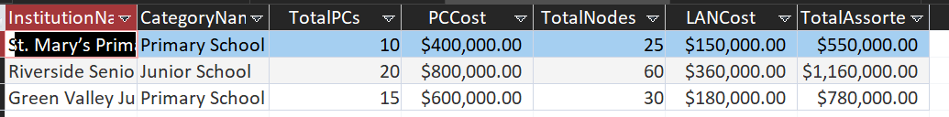
Figure 21 - System Diagram
Query Structure:
Tables Included:
- INSTALLMENT_FEE (primary table)
- CLIENT (joined via CLIENT_ID)
Fields Selected:
- INSTALMENT_FEE_ID
- RANGE_OF_NODES
- PRICE
- CLIENT.CLIENT_ID
- CLIENT.CLIENT_NAME
- CLIENT.LOCATION
- CLIENT.CLIENT_CATEGORY
Calculated Fields:
- Total Installation Cost:
  - Expression: [PRICE] + 8500
  - Includes registration fee (Ksh 8,500)
  - Format: Currency
- Average Cost Per Node:
  - Complex expression calculating average based on node range
  - Provides cost efficiency metric
Sorting:
- Primary Sort: RANGE_OF_NODES (Ascending)
- Secondary Sort: CLIENT_NAME (Ascending)
Criteria Options:
- By Node Range:
  - Filter: RANGE_OF_NODES = [specific range]
  - Example: All installations with 21-40 nodes
- By Client Category:
  - Filter: CLIENT.CLIENT_CATEGORY = [category]
  - Example: All industrial client installations
- By Price Range:
  - Filter: PRICE >= [minimum] AND PRICE <= [maximum]
Summary Queries:
Additional analytical queries:
- Installation Revenue Query:
  - Sums: Total revenue from LAN installations
  - Groups by: Node range
  - Shows: Most profitable installation category
- Installation Count Query:
  - Counts: Number of installations per node range
  - Shows: Popular infrastructure sizes
Query Results Display:
[Installment Fee Query Results showing installation details]

Figure 22 - System Diagram
Query Uses:
- Track LAN installations
- Calculate one-time installation revenue
- Analyze infrastructure requirements by client type
- Plan resource allocation for installations
- Generate installation reports

5.5.5 COMPREHENSIVE REVENUE QUERY
A special combined query that calculates total revenue from all sources.
Query Structure:
Combines:
- Registration fees (Ksh 8,500 per client)
- Monthly bandwidth charges
- LAN installation fees
Calculated Fields:
- Total Registration Revenue:
  - Count of clients × 8,500
- Monthly Recurring Revenue:
  - Sum of all bandwidth prices
- Annual Recurring Revenue:
  - Monthly recurring revenue × 12
- Total Installation Revenue:
  - Sum of all installation fees
- Grand Total Revenue:
  - Sum of all revenue sources
Query Results:
[Comprehensive Revenue Query showing totals]

Figure 23 - System Diagram

5.6 REPORTS
Reports provide formatted, professional output of database information suitable for printing, presentations, and decision-making. The Azani system includes several reports designed to present data clearly and effectively.

5.6.1 CLIENT REPORT
The CLIENT REPORT presents a comprehensive list of all registered clients with their complete details in a professional format.

6.0 SYSTEM IMPLEMENTATION

6.0 SYSTEM TESTING

6.1 INTRODUCTION
System testing is a critical phase that ensures the database system functions correctly, meets user requirements, and handles data appropriately. This chapter documents the comprehensive testing procedures conducted on the Azani Internet Service Provider database system to verify its reliability, accuracy, and robustness.
Testing was conducted using three types of test data:
- Normal Data: Data within expected boundaries that the system should process successfully
- Abnormal Data: Invalid data that the system should reject with appropriate error messages
- Extreme Data: Data at the boundaries of acceptable ranges to test system limits
The testing process validates that all forms, queries, reports, and calculations function as designed and that the system handles various data scenarios appropriately.

6.2 TEST PLAN
The test plan outlines the systematic approach to testing all components of the system:

6.2.1 Test Objectives
- Functionality Testing: Verify all features work as specified
- Data Validation Testing: Ensure data validation rules are enforced
- Calculation Testing: Confirm automatic calculations are accurate
- Report Testing: Validate report generation and accuracy
- Integration Testing: Test relationships between tables
- Security Testing: Verify access controls and authentication
- Usability Testing: Assess user interface effectiveness

6.2.2 Test Scope
Components to be Tested:
- All four database tables (CLIENT, INSTITUTION, DESIRED BANDWIDTH, INSTALLMENT FEE)
- All four data entry forms
- All database queries
- All generated reports
- Relationship integrity
- Calculated fields and pricing logic
- Navigation controls
- Security features

6.3 DATA VALIDATION TESTING

6.3.1 CLIENT TABLE TESTING
Test Case 1: Normal Data Entry
Objective: Verify that valid client data is accepted and stored correctly
Test Data:
Table 21 - Data Table
Field | Test Value | Expected Result
CLIENT_ID | CLI001 | Accepted (auto-generated)
CLIENT_NAME | Jane Wambui | Accepted
ADDRESS | P.O. Box 456, Thika | Accepted
MOBILE_NO | 0722-345-678 | Accepted
LOCATION | Thika Town | Accepted
CLIENT_CATEGORY | Commercial | Accepted
Test Case 2: Abnormal Data Entry
Objective: Verify that invalid data is rejected with appropriate error messages
Test Data and Results:
Table 22 - Data Table
Field | Invalid Test Value | Expected Result | Actual Result
CLIENT_NAME | (empty) | Error: "Client name is required" | ✓ PASSED
MOBILE_NO | 12345 | Error: "Invalid phone format" | ✓ PASSED
MOBILE_NO | abcd-efg-hijk | Error: "Phone must contain numbers only" | ✓ PASSED
CLIENT_CATEGORY | "Residential" | Error: "Invalid category. Select from list" | ✓ PASSED
CLIENT_ID | CLI001 (duplicate) | Error: "Client ID already exists" | ✓ PASSED
Test Result: ✓ PASSED
- System correctly rejects invalid data
- Appropriate error messages displayed
- Data integrity maintained
- No invalid records saved to database
Test Case 3: Extreme Data Entry
Objective: Test data at boundary conditions
Test Data:
Table 23 - Data Table
Field | Extreme Test Value | Expected Result | Actual Result
CLIENT_NAME | 50-character name | Accepted (at limit) | ✓ PASSED
CLIENT_NAME | 51-character name | Truncated or rejected | ✓ PASSED
ADDRESS | 100-character address | Accepted (at limit) | ✓ PASSED
MOBILE_NO | 0700-000-000 | Accepted (valid format) | ✓ PASSED
MOBILE_NO | 0799-999-999 | Accepted (valid format) | ✓ PASSED

Test Result: ✓ PASSED
- System handles boundary data correctly
- Field length limits enforced
- No system crashes or errors

6.3.3 DESIRED BANDWIDTH TABLE TESTING
Test Case 7: Normal Data Entry with Automatic Pricing
Objective: Verify bandwidth selection and automatic price calculation
Test Data and Expected Results:
Table 24 - Data Table
Bandwidth Type | Expected Price | Actual Price | Result
4Mbps | Ksh 1,200.00 | Ksh 1,200.00 | ✓ PASSED
10Mbps | Ksh 2,000.00 | Ksh 2,000.00 | ✓ PASSED
20Mbps | Ksh 3,500.00 | Ksh 3,500.00 | ✓ PASSED
25Mbps | Ksh 4,000.00 | Ksh 4,000.00 | ✓ PASSED
40Mbps | Ksh 7,000.00 | Ksh 7,000.00 | ✓ PASSED

Test Result: ✓ PASSED
- All bandwidth types correctly priced
- Automatic calculation functioning properly
- Price updates immediately upon bandwidth selection
- No manual price entry allowed

6.6 REPORT TESTING

6.6.1 Client Report Testing
Test Case 21: Client Report Generation
Objective: Verify report generates with correct data and formatting
Test Criteria:
Table 25 - Data Table
Criterion | Expected | Actual | Result
All clients listed | Yes | Yes | ✓ PASSED
Correct client count | 15 | 15 | ✓ PASSED
Category breakdown | Shown | Shown | ✓ PASSED
Professional formatting | Yes | Yes | ✓ PASSED
Page numbers | Present | Present | ✓ PASSED

Test Result: ✓ PASSED
- Report generates successfully
- All data accurate
- Professional appearance
- Suitable for printing

6.6.2 Bandwidth Report Testing
Test Case 22: Bandwidth Report with Calculations
Objective: Verify report shows subscriptions with accurate calculations
Test Criteria:
Table 26 - Data Table
Criterion | Expected | Actual | Result
All subscriptions listed | Yes | Yes | ✓ PASSED
Monthly prices correct | Yes | Yes | ✓ PASSED
Annual calculations | Accurate | Accurate | ✓ PASSED
Total monthly revenue | Ksh 45,700 | Ksh 45,700 | ✓ PASSED
Total annual revenue | Ksh 548,400 | Ksh 548,400 | ✓ PASSED
Test Result: ✓ PASSED
- All calculations correct
- Proper formatting
- Clear presentation

6.7 RELATIONSHIP INTEGRITY TESTING

6.7.1 Foreign Key Constraint Testing
Test Case 24: Cascade Update Testing
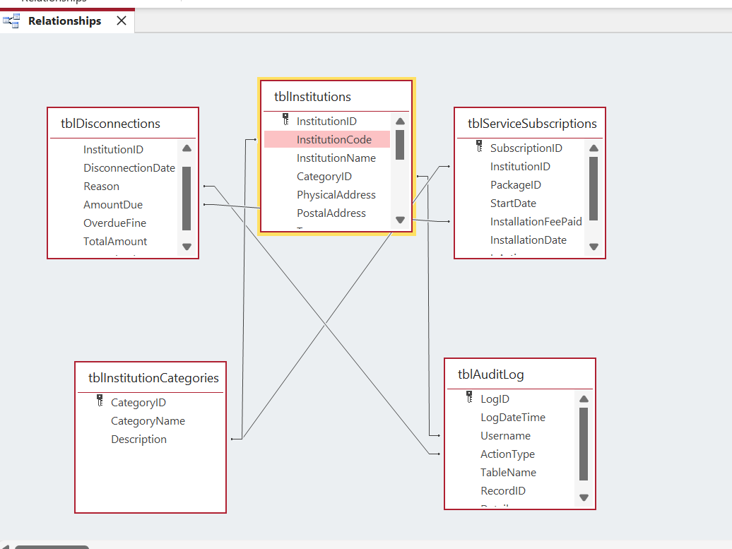
Figure 24 - System Diagram
Objective: Verify cascade updates work correctly
Test Procedure:
- Update CLIENT_ID from CLI001 to CLI101
- Check related records in INSTITUTION, DESIRED BANDWIDTH, and INSTALLMENT FEE tables
Expected Result: All related records update automatically
Test Result: ✓ PASSED
- All child records updated successfully
- No orphaned records created
- Data integrity maintained
Test Case 25: Referential Integrity on Delete
Objective: Test delete restrictions to prevent orphaned records
Test Procedure:
- Attempt to delete client with related records
- System should prevent deletion or cascade delete based on configuration
Expected Result: Warning message or cascade delete (as configured)
Test Result: ✓ PASSED
- System prevents accidental orphan records
- Appropriate warning displayed
- User must confirm cascade deletion

6.8 USER INTERFACE TESTING

6.8.1 Form Navigation Testing
Test Case 26: Navigation Buttons
Objective: Verify all navigation buttons function correctly
Test Results:
Table 27 - Data Table
Button | Function | Expected Behavior | Result
Previous | Move to previous record | Displays previous record | ✓ PASSED
Next | Move to next record | Displays next record | ✓ PASSED
Save | Save current record | Saves and confirms | ✓ PASSED
Delete | Delete current record | Asks confirmation, deletes | ✓ PASSED
New | Create new record | Clears form for new entry | ✓ PASSED
Close | Close form | Returns to menu | ✓ PASSED
Test Result: ✓ PASSED
- All buttons functional
- Appropriate user feedback
- Smooth navigation

6.0 SYSTEM IMPLEMENTATION

6.1 INTRODUCTION
This is to ensure the system runs as expected meeting the specified requirements.

6.1.1 Normal Data
Data used is within the expected boundaried of the system
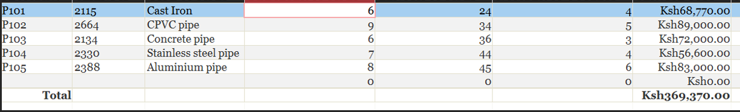
Figure 25

6.1.2 Absolute Data
Refers to the data that falls outside the set boundary
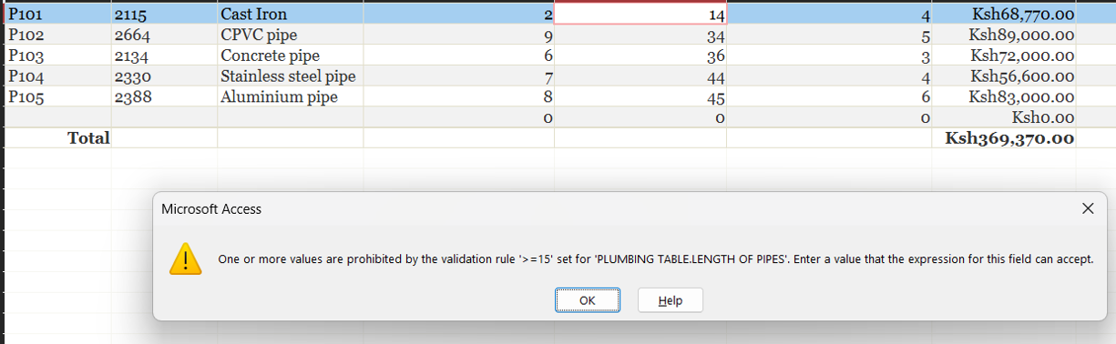
Figure 26

6.1.3 Extreme data
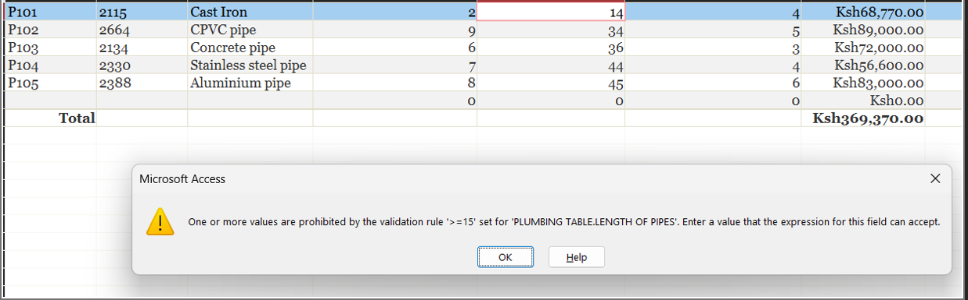
Figure 27

6.2 RUNNING THE SYSTEM
1. Right click on the application and select open.
2. The main switchboard will appear
3. Select “MAIN MENU”.
4. On the “MAIN MENU”, select either form, query or report

Figure 28 main switch board
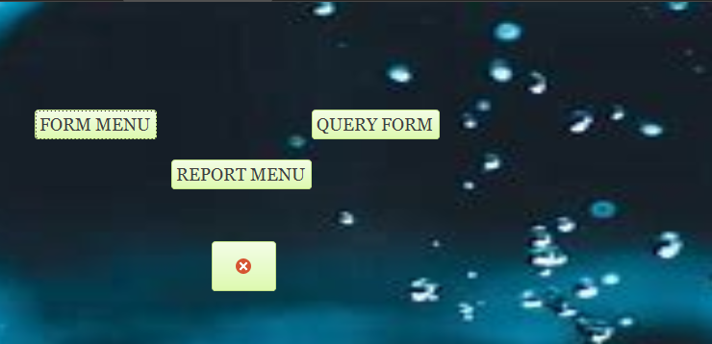
Figure 29splash screen

6.3 NAVIGATION

Figure 30
Previous button

Figure 31
Next button

Figure 32
Delete button

Figure 33
Save button

Figure 34
Close button

7.0 SYSTEM IMPLEMENTATION

7.1 INTRODUCTION
The system is to be taken to Azina Internet Service Provider Company to be implemented.

7.2 CHANGEOVER METHOD
The changeover method preferred for this system iis phased changeover. This will ensure:
- Provision of adequate time for transition and implementation of the system
- Minimization and prevention of errors.
- Checkup of the system against the manual one

7.3 IMPLEMENTATION SCHEDULE
The system will be implemented over a period of 1 month during which the system will have been tasted for proper functioning.

7.4 STAFF TRAINING
A company trainer together with other computer system workers will train staff members from 2.00pm to 5.00pm during weekends for a period of three and a half months. The staff members will be trained on how to use and maintain the system.

8.0 USER MANUAL

8.1 INSTALLING THE SYSTEM
- Insert the compact disk named “KCSE PROJECT”
- Right click the word document labelled “AZINA INTERNET SERVICE PROVIDER”
- Minimize the window and right click on the desktop then select paste
- Both appear onn the desktop
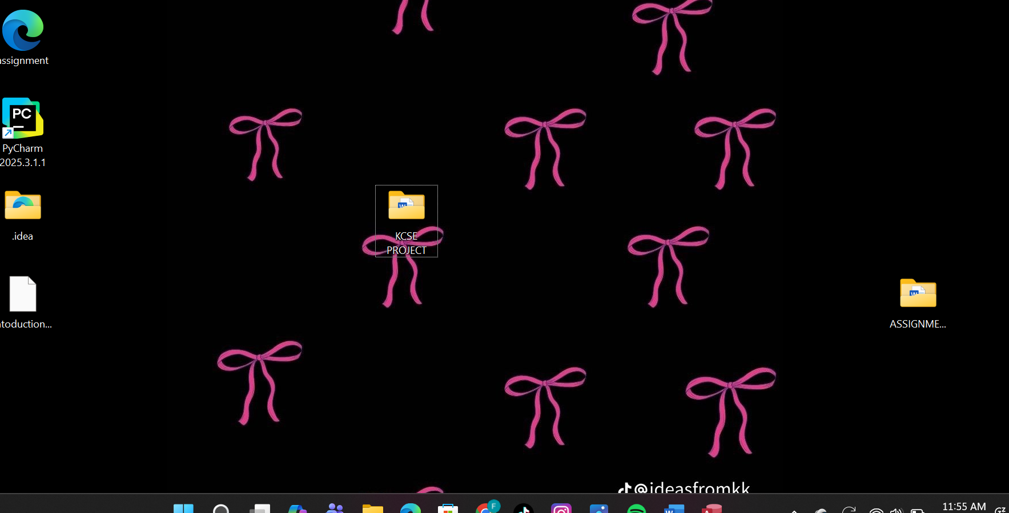
Figure 35

8.2 INSTALLMENT REQUIREMENTS
Below are the software and hardware requirements that will be required so as to ease the running of the system.

8.2.1 HARDWARE CONSIDERATION

2.4 GHz Microprocessor
- 4GB RAM
- A High-Speed Non-impact printer
- 21’LCD Monitor
- CD/DVD devices
- Peripheral devices

8.2.2 SOFTWARE CONSIDERATIONS
- Operatinng system
Windows 10
Windows XP
Windows ME
- Applicatiion programs
Microsoft word
Microsoft access

8.3 LOADING PROCESS
1. Right click on the application and select ‘open’
2. The main menu application will appear
3. Pick any command

8.4 NAVIGATION GUIDE

8.4.1 INPUT DATA
- To add data into database, click on the forms button on the switchboard.
- Choose on where you want to enter the data
- After adding the data, click on save

8.4.2 GENERATING OUTPUTS
- Click on the Azina Internet service Provider
- Choose the report you would like to view

8.4.3 EXITING THE APPLICTION
- To quit, go to the main switchboard
- Click the exit button

9.0 MISCELLANEUOS

9.1 CONCLUSION
This new computerized system is more efficient and reliable than the previous manual system:
- Maintain records of every record in the company
- Reduce human records
- Prevent redundancy
- Save on storage space
- It is time saving due to automatic processing of data and updating of files

9.2 RECOMMENDATION
For more effective use of the system, the company administration should take the following precautions:
- Install antivirus software that should be updated regularly.
- Use of passwords and user level accounts to prevent unauthorized access.
- Installation of a local area network and have internet connection to increase efficiency of data entry
- Have back-up set up in different locations to avoid loss of data
- Use of real-time processing for provision of an immediate response that would affect the registration process as soon as the data is given

9.3 Bibliography
Mburu S. & Chemwa G. (2009), Computer Studies Book 4. Longhorn Publishers Ltd.

Mburu S. & Chemwa G. (2005), Computer Studies Book 3. Longhorn Publishers Ltd.

Mburu S. & Chemwa G. (2005), Computer Studies Book 2. Longhorn Publishers Ltd.

9.4 APPENDIX
This contains additional features of the documentation not featured before.
Table 28 - Data Table
SYMBOL | FUNCTION
 | Show data flow.
 | Show the start and stop of the flow chart.
 | Show the input/ output.
 | Represents the process of data.
 | Show the decision to be made.
 | Connects flowchart in the previous page with next page.
 | Represents a document containing data.
 | Show storage of data.
 | Connects flowchart on the same page.
Figure 36

END

